Introduction
In 2016, one of the most famous and most exemplary DDoS attacks happened; more than a million devices attacked DNS provider Dyn, resulting in major online services like Netflix, Airbnb, and the BBC being cut off. More recently, social media service Bluesky was attacked for 24 hours on April 15th by a pro-Iran hacktivist group. Distributed Denial of Service attacks, or DDoS attacks are attempts to make digital infrastructure unavailable by flooding them with requests from multiple sources.
Denial of Service attacks are (one of the) most common network security threat experienced by Enterprises, Governments and Educational bodies, while the customers of Service Providers (e.g. ISPs and Data Centers) remain to be the number one target of DDoS attacks [1] while network-layer attacks target vital Internet structure [2. DDoS attacks are easy to execute, even without technical knowledge [3]. AI integrated attacks and increasing sophistication only prove that DDOS attacks are becoming more dangerous: A record of 31.4 terabytes per second attack has been stopped by an Internet-service provider [4].
Due to the relevance of DDoS attacks, many researches have been conducted on detection, defending, and mitigating attacks. In this research, we investigate the severity of a DDoS attack on its societal impact, where we use Google Alerts as a source to identify DDoS attacks. These alerts are collected in a database, which has been annotated as “Arrest”, “Attack”, “Research”, and “Other” in prior research [5].
We want to see how several dimensions influence the social ‘popularity’ of a DDoS attack. This creates an insight into public perception of DDoS related events, and how this changes historically, as well as gives insight into socioeconomic damage perceived through these events. Possibly, this insight can be used to make more educated decisions in a cost/benefit analysis on cybersecurity.
This research records socioeconomic dimensions in DDoS related events (news articles, blogs, etc). The dimensions we record, are: Political, Economical, Legal, Social, and Technical impact. A common analysis models which combines these factors, is the PESTLE analysis model, which will be used in this research. Based on this analysis model, the research aims to create a tool to visualize the insight gained from this dataset.
The main goals of this research are:
- Analyse annotated Google alert dataset with PESTLE analysis model
- Create valuation model based on analysis
- Expand current annotated Google alert dataset with analysis data
- A tool that can generate insight into the (analysed) impact of a DDoS attack given a dataset
This research is comprised of two main research questions:
RQ1: What is the impact of PESTLE dimensions on the news popularity of a DDOS attack?
RQ2: How do we create a measurement tool to contextualize/visualize the impact (based on the annotated dataset)?

Methodology and approach
The dataset used in this research has already been collected. This dataset, comprised of Google Alerts, has been described and collected by Abhishta [6]. The dataset consists of Google Alerts on the keywords “DDoS” and “Distributed Denial of Service”. The dataset has been annotated as “Arrest”, “Attack”, “Research”, and “Other” in research by Wim Kamerman.
This research uses analysis on article level (per datapoint) and on event level (per DDoS event). This research performs a manual, qualitative analysis on PESTLE dimensions occurring in the dataset on article level. We extract the relevant features in Google Alert notifications and store this metric in the dataset. Each PESTLE dimension is operationalized using observable indicators extracted from the text. Examples of this, could be; targeting of government (Political), public service provider targeting (Social), attack size mentioned (Technological), or the damage done is mentioned (Economical).
We operationalize the ‘popularity’ of an event as the number of articles referring to the same DDoS event within a defined timeframe. A subset of the dataset will be manually annotated and used to train a supervised text classification model to automatically detect PESTLE-related features. This process can be assisted via a local Large Language Model provided by the University of Twente to help code this artifact, and by using the previous research from Kamerman. The Machine Learning and text classification models for text annotation, provided by Kamerman, will be used and expanded. A regression analysis will be conducted to determine the relationship between PESTLE dimensions and the popularity of DDoS events.

Work programme
This module consists of 11 weeks. In this research, there are two substantial content-related tasks which need to be completed in the given timeframe:
- Give PESTEL value to dataset
- Create tool to gain insight into ‘value’ of alerts about DDOS
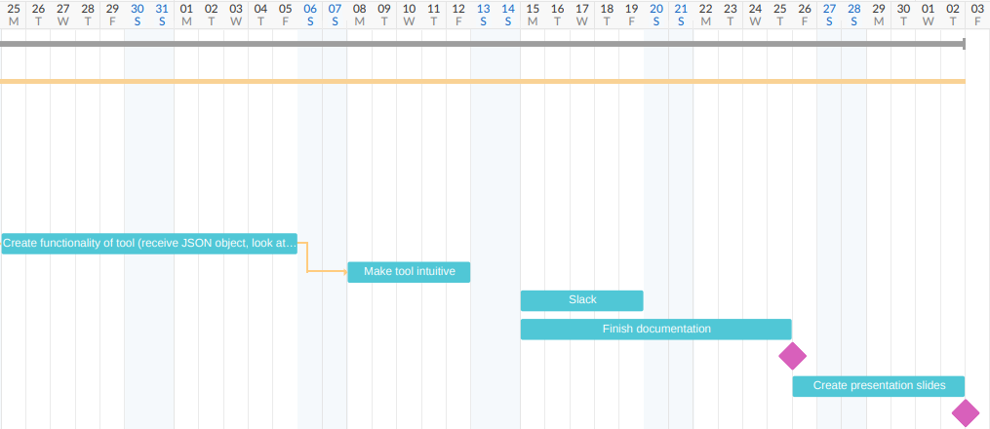
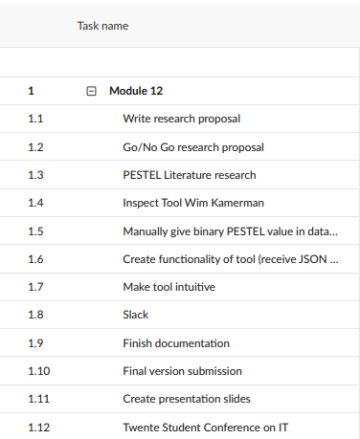
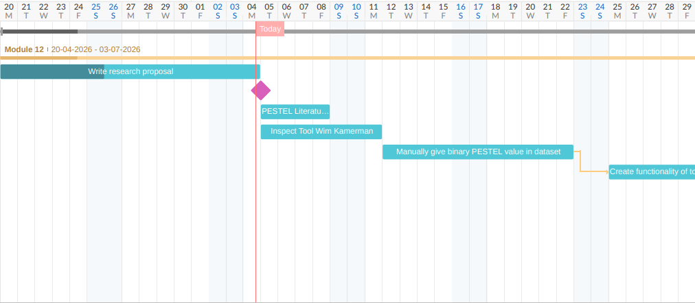

Next to that, we also need time for documentation (in-code and in the paper), preparing the presentation for the Twente Student Conference on IT, and we need time for setbacks. Inspired by the Student Manual, which states a 2 week proposal stage and a two week conference prepare stage, we gain the following schedule:
During the paper writing part, we divided the time as follows. The first week, time has to be made clear for setup and literature research. Since the research this paper is based on is from 2018, the libraries and code written are outdated, which will likely give some problems early on. Manually going through (a sample of) the dataset will be labour intensive. This process could be sped up using large language models, but a human viewpoint is probably preferred, which is why we think 2 weeks will be necessary to properly perform this task. Creating the tool, and making it intuitive and usable, will likely cost three weeks of time. A large part of this process can only be started once the dataset has been annotated, which is why it is essential we do the annotation correctly.
In the end, we have reserved 2 weeks of time for documenting purposes, as well as slack and review moments. It is likely that review moments are spread throughout the module; for simplification reasons we have grouped them together in the last weeks. In these last weeks, the conference needs to be prepared with slides, and the presentation must be practiced thoroughly. This will likely take another week. Together this research spans the entire module.

Bibliography
[1] NETSCOUT Observability, Cybersecurity, DDOS, & AIOPs Solutions. (z.d.). NETSCOUT. https://pages.arbornetworks.com/rs/082-KNA%20087/images/12th%20Worldwide%20Infrastructure%20Security%20Report.pdf,%202016
[2] 2025 Q4 DDoS threat report: A record-setting 31.4 Tbps attack caps a year of massive DDoS assaults. (2026, 23 februari). The Cloudflare Blog. https://blog.cloudflare.com/ddos-threat-report-2025-q4/
[3] UNMASKING THE SWARM: UNMASKING THE SWARM: THE EVOLVING TACTICS OF THE EVOLVING TACTICS OF BOTNET-DRIVEN DDoS ATTACKS. (z.d.). In NETSCOUT (ISSUE 16: FINDINGS FROM 2H 2O25). NETSCOUT.
[4] Defending the Internet: How Cloudflare blocked a monumental 7.3 Tbps DDoS attack. (2025, 27 juni). The Cloudflare Blog. https://blog.cloudflare.com/defending-the-internet-how-cloudflare-blocked-a-monumental-7-3-tbps-ddos/
[5] Kamerman, W. (2018). Classification of Event-Related Google Alerts Using Machine Learning. https://essay.utwente.nl/77011/
[6] Abhishta, A. (2019). The blind man and the elephant. https://doi.org/10.3990/1.9789036549127

Notities over onderzoek:

Groter onderzoek: Socioeconomische invloed van DDOS aanvallen (in bedrijven)
Specifieke opdracht: Gebruik ‘Text classification’ (Machine Learning) (ga ik zo meer over opzoeken) om specifieke event te filteren (op een gegeven dataset).

Machine learning op DDOS (link)

Notities meeting 1:
Abhishta is weg van 26 tot 6, JW van 8 tot 29
JW gaat over go/no go van 4 mei
Goal: Create artifact (system, dynamic) to be able to understand/interpret/visualize/quantify severity of DDOS attack on PESTEL dimensions
Context: Study has been going since 2018. Because cyber attacks can be a big problem, we want to measure severity/impact of DDOS attack on political, economical, social, technical, environmental en legal dimensions. We have collected a large database of google alerts, which are notifications of news articles about DDOS/Distributed denial of service attacks. We want to see trends, be able to identify incidents, and quantify impact. We want to know: What makes an attack ‘popular’ for media to report on. In other words: Make the data usable for people who want to understand/visualize/contextualize the severity of a DDOS attack.
Dataset:
Json met als attributen {Web/News; Date (onbekend format), link, Content, Content_NER (?), Content_Title, Content_Title_NER, Cat4_id, cat4_name (research, attack, other, arrest), cat2a_id, cat2a_name (research, attack, other, arrest), Content_body, Content_body_NER, Content_Double_Title, Content_Triple_Title, Content_Triple_Title_NER, Content_Double_Body}

Pitch:
Topic 14 Pitch: Socioeconomic influence of DDoS
DDoS or Distibuted Denial of Service attacks are cyberattacks that try to kill a service by flooding the service with access requests. They are very annoying attacks on companies or governments, potentially killing a service for an extended period, resulting in significant economic or societal impact. Attacks happen all the time, some of them becoming major headlines, some are quickly forgotten.
We are researching different dimensions (PESTLE) of societal influence impacting the ‘popularity’ of a DDoS event. In an extensive dataset, we aim to create a tool to show societal trends in the subset. We us machine learning, specifically text classification techniques, as well as a trained model created in a previous, associated research, to annotate the dataset. Our main questions are:
RQ1: What is the impact of PESTLE dimensions on the news popularity of a DDOS attack?
RQ2: How do we create a measurement tool to contextualize/visualize the impact (based on the annotated dataset)?

Database of more than 8 years of google alert events

Creating an artifact which can be fed subset of news events, and show societal influence trends in that specific subset

Dieper ingaan op welke tools ik ga gebruiken voor trends herkennen (machine learning ding van Wim, text classification, literatuur(?))
Ik wil trends zien door de hele database zien, niet specifiek per event ofc. Dus je voert een dataset in, en krijgt daar de trends te zien (ene dimensie is belangrijk, deze woorden komen veel voor)
Hoe is het embedded in society?

